Brandon Rumbarger
Advanced Machine Learning
October 25th 2026
Cats and Dogs Image Classification
The Cats and Dogs image dataset was used to build models that predict whether an image contains a cat or a dog. Two approaches were compared: a convolutional neural network trained from scratch and a pretrained VGG16 network. The experiments examined how changing the number of training images affected model performance. Accuracy and loss were used to compare the models. Validation results were used during model development, while test results measured performance on images held out from training.
The dataset was divided into training, validation, and test sets. Three training sample sizes were evaluated: 1,000 images, 5,000 images, and 23,000 images. The validation set contained 500 images, and the test set contained 500 images. The validation and test sets were kept the same across the experiments to make the results easier to compare.
The first model was a convolutional neural network trained from scratch. This model learned image features using the assignment dataset. Dropout and global average pooling were used as part of the model design. The model was trained using RMSprop and binary cross entropy, and the saved model with the lowest validation loss was used for the final test evaluation.
The second model used VGG16 pretrained on ImageNet. The convolutional base was frozen, and a new classification layer was trained to distinguish cats from dogs. This allowed the model to reuse image features learned from a much larger dataset. The same three training sample sizes were evaluated. Both approaches were trained for up to 10 epochs, and the checkpoint with the lowest validation loss was selected.
The CNN trained from scratch achieved 66.0% test accuracy with 1,000 training images. Increasing the training sample to 5,000 images improved test accuracy to 78.2%. Using 23,000 images resulted in 81.4% test accuracy. Test loss was 0.6268, 0.5051, and 0.3769, respectively. Overall, the scratch CNN benefited from having more training examples, with test accuracy increasing and test loss decreasing as the training sample grew.
The pretrained VGG16 model performed better than the scratch CNN at each training sample size. With 1,000 images, VGG16 achieved 94.4% test accuracy. It also achieved 94.4% with 5,000 images, and reached 95.2% with 23,000 images. Test loss decreased from 0.3107 with 1,000 images to 0.2081 with 5,000 images and 0.2035 with 23,000 images. These results show that pretrained image features were effective even when the training sample was relatively small.
The results for all six experiments are summarized below. Validation accuracy is shown for the checkpoint selected by lowest validation loss; it is not necessarily the maximum validation accuracy reached during training.
Model | Training images | Validation accuracy | Test accuracy | Test loss
CNN from scratch | 1,000 | 69.8% | 66.0% | .6268
CNN from scratch | 5,000 | 76.4% | 83.0% | 0.5051
CNN from scratch | 23,000 | 86.2% | 81.4% | .3769
Pretrained VGG16 | 1,000 | 97.6% | 94.4% | 0.3107
Pretrained VGG16 | 5,000 | 98.2% | 94.4% | 0.2081
Pretrained VGG16 | 23,000 | 98.2% | 95.2% | 0.2035
The results show that increasing the training sample improved the scratch CNN considerably. Its test accuracy increased by 15.4 percentage points between 1,000 and 23,000 images. VGG16 improved by 0.8 percentage points over the same range, starting from a much higher level of accuracy. The pretrained model achieved the strongest test result, with 95.2% accuracy and 0.2035 test loss using 23,000 images.
Figure 1. Test accuracy by model and training sample size
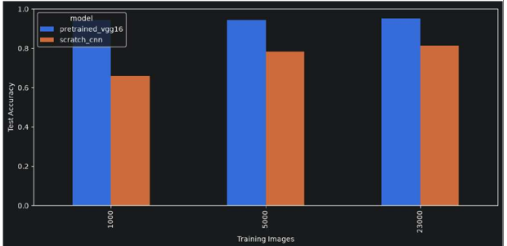

Test loss by model and training sample size
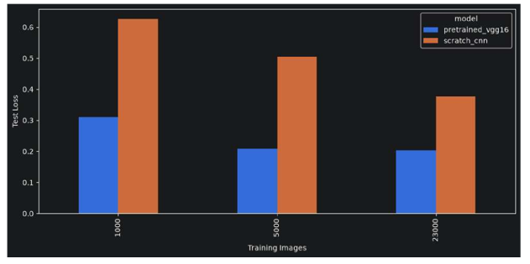
The charts show the same overall pattern as the table. The scratch CNN improved as more training images were provided, but its performance remained below VGG16. The pretrained network achieved high accuracy even with the smallest sample. The difference between the two approaches was largest with 1,000 images and remained substantial with 23,000 images.
These experiments indicate that both training sample size and model choice affect image classification performance. A larger sample helped the CNN trained from scratch learn more useful image features. However, the pretrained VGG16 model performed better at all three sample sizes because it could reuse features learned during ImageNet training. In this set of experiments, transfer learning was more effective than training the full feature extraction process from scratch.
There are limitations to these results. The experiments used one set of training settings for each model and did not repeat training with multiple random seeds. The VGG16 convolutional base remained frozen, so fine tuning was not tested. The results also describe performance on the selected dataset and should not be treated as a guarantee of performance on every real world image.
The CNN trained from scratch achieved its best result with 23,000 training images, reaching 81.4% test accuracy. The pretrained VGG16 model achieved 95.2 test accuracy with the same sample size and outperformed the scratch model in all three comparisons. The results show that increasing the amount of training data can improve performance, but the choice of network also matters. For this assignment, pretrained VGG16 was the most effective approach.

